Instructions for assignment 2 – SQL Server Installation or sign-in & basic commands
EACH DELIVERABLE IS NOTED WITH TWO DOLLAR SIGNS IN FRONT ($$) AND IN RED
**If you have your own machine and do not yet have SQL Server Developer or Enterprise Edition installed, then follow these instructions to install SQL Server 2019 Developer Edition. This is highly recommended as certain extra credit exercises require you to have your own installation. If you do not have a machine to be able to do this, then skip to the next major section.
SQL SERVER 2017 DEVELOPER EDITION INSTALLATION INSTRUCTIONS:
- Go to https://www.microsoft.com/en-gb/sql-server/sql-server-downloads
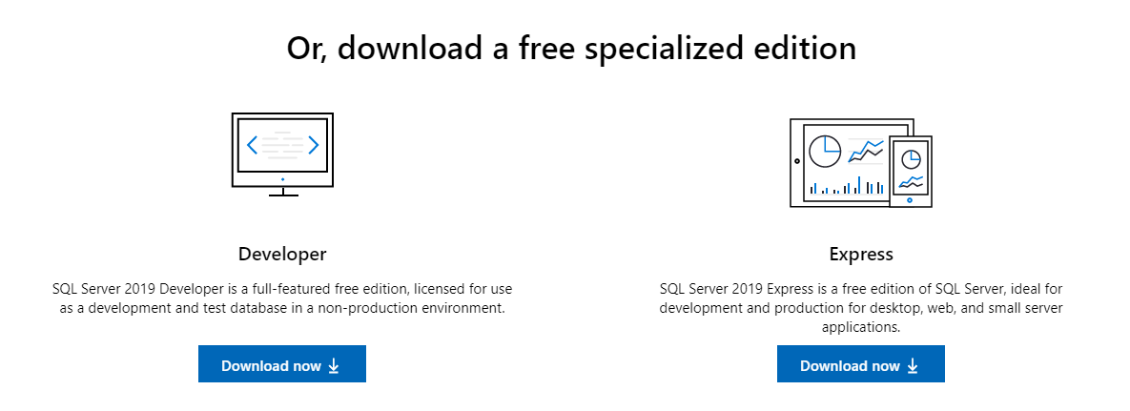
- Click on “Download now” under the “Developer” version (DO NOT CLICK ON “Download free trial”)
- Double-click on the downloaded file and the following should show up:
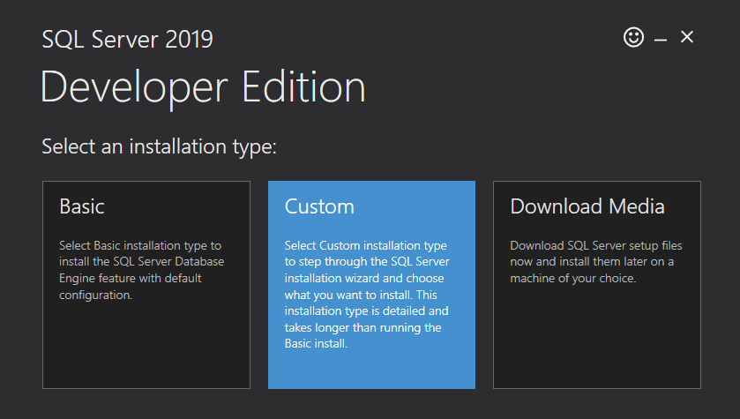
- Select “Custom” and then “Install” on the next screen once you verified the location of the media is acceptable for your machine. The download can take a few hours depending on your download speed.
- Once complete, the following screen should appear:
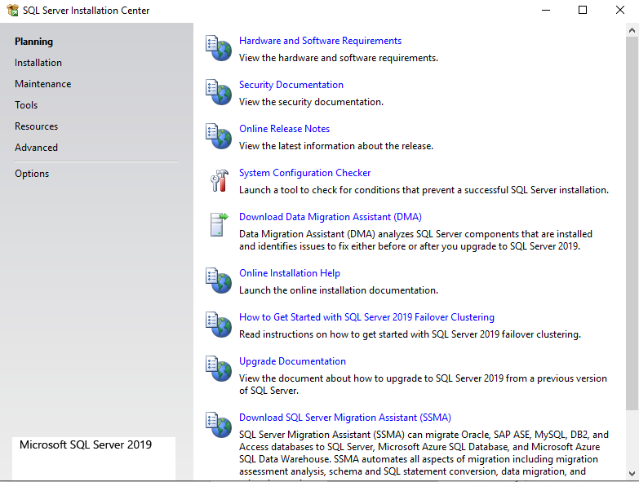
- Run “System Configuration Checker” to ensure there are no issues. If there are, then address them.
- Click on “Installation” in the left-side panel and the following should appear:
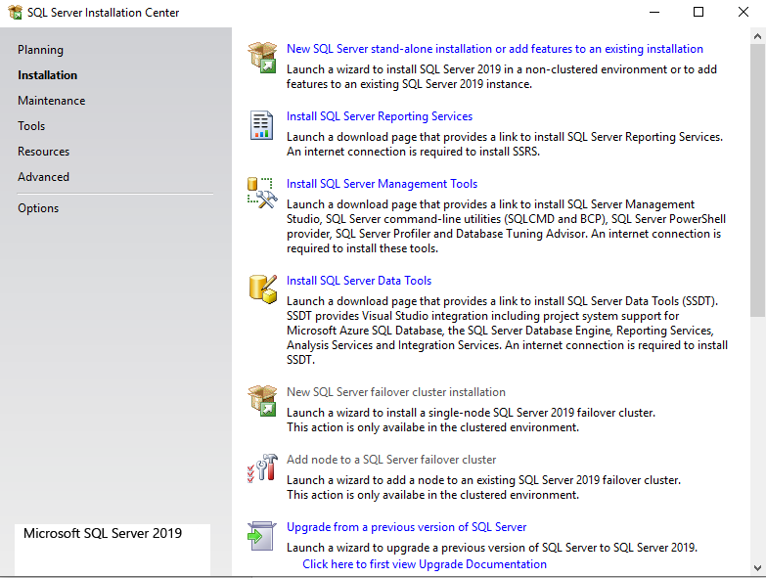
- Click on “New SQL Server stand-alone installation or add features to an existing installation”
  - NOTE: Do not close this screen as you will need to come back to it to install the “Management Tools”
- Click “Next”, then “accept terms” and click “Next” again
- You should then arrive at a screen similar to the below. You can ignore if you get a “warning” on the Windows Firewall check.
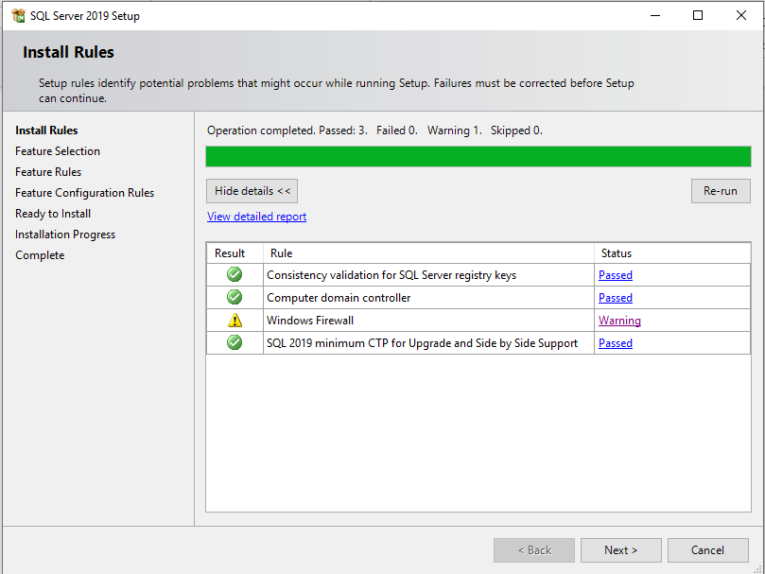
- Continue to click “next” with default settings until the following screen is reached:
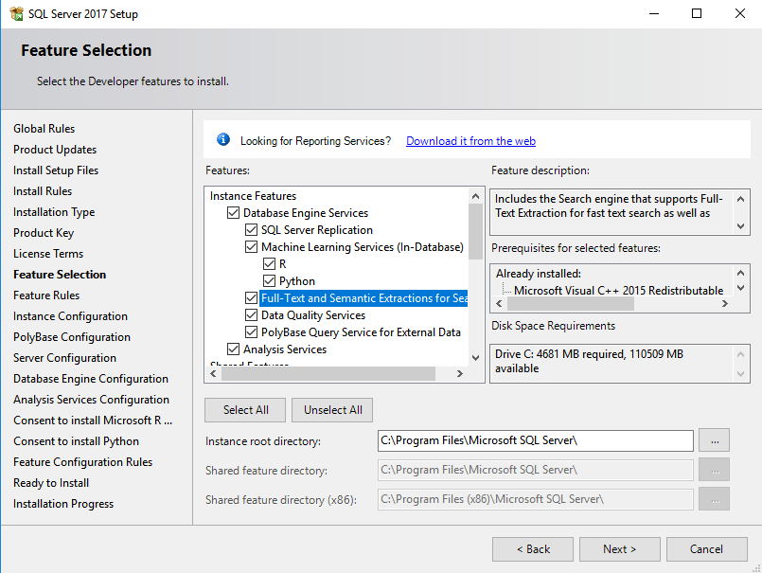
- On this screen, if you have sufficient capacity on your system (about 15GB of disk space and at least 1GB of RAM), then click on “Select All”. If not, then select at least the “Database Engine Services” and all the “Client Tools”. Without at least these selections, you will not be able to perform all the activities for this class.
  - NOTE: If you have issues with “R Services” or “Polybase” (Requires a certain version of Java), you may de-select these Database Engine Service selections as they will not be used in this course.
- Once done with selections, click “next”
- On the next screen (instance configuration) select “Default Instance” and click “next”
  - NOTE: If you already have a SQL Server installation on your machine with a default instance, then you will need to select “Named Instance” and provide a name. There can only be one default instance per machine, regardless of the number of SQL Server installation versions on that machine.
- Click next until you get to the “Database Engine Configuration” screen (shown below):
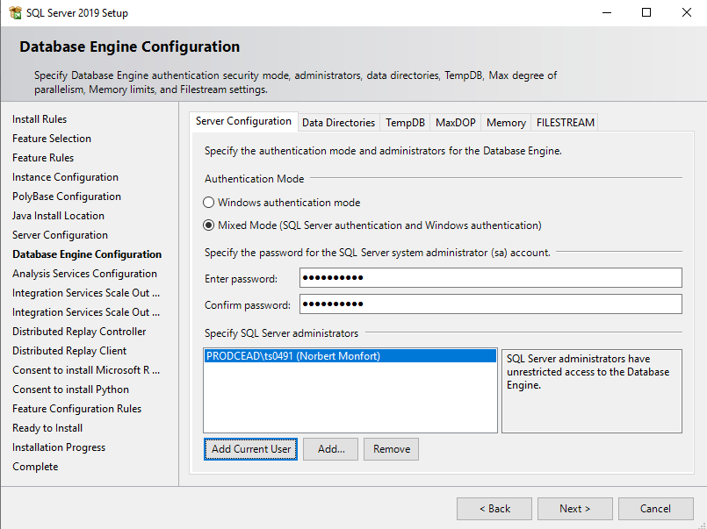
- On the “Database Engine Configuration” screen, select “Mixed Mode”, provide a strong password (called the SA password) and then click on “Add Current User” to add your Windows account to the SQL Server Administrators group.
- On the next screen “Analysis Services Configuration”, click on “Add Current User” as shown below:
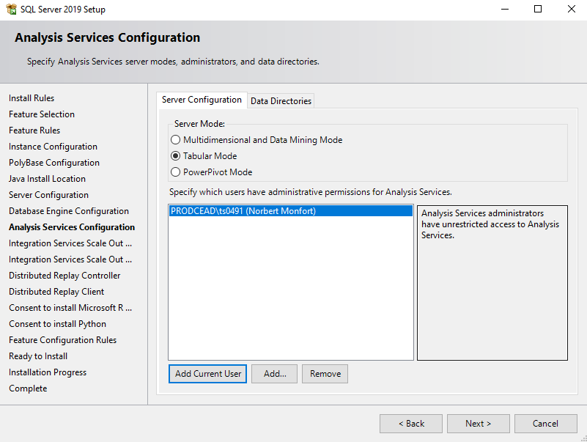
- Accept the defaults on the rest of the screens, but click on “Accept” when you arrive at the “Consent to install Microsoft R” and “Consent to install Python” screens.
- Finally, you should arrive at the following screen:
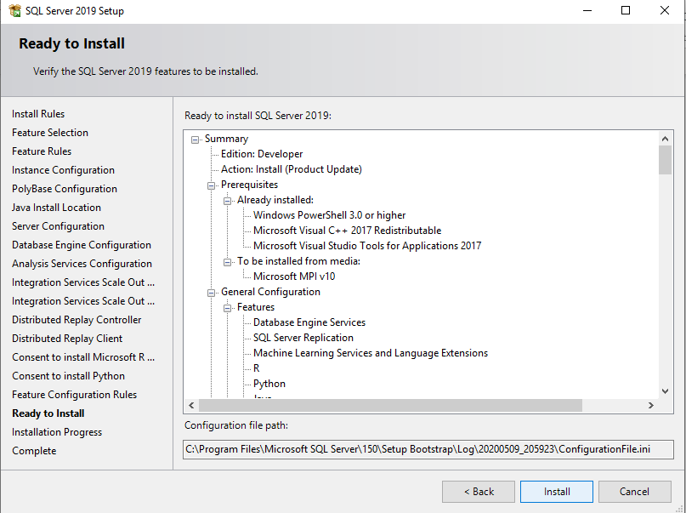
- Click on “Install” and you should be good to go to install the SQL Server!
  - NOTE: If you have installation problems, research them as much as you wish, but also consider reducing the install down to the bare minimum of “Database Engine Services” without R & Polybase, while including “client tools” as that’s all that is needed for this course.
  - NOTE: Failures during the installation are not a problem for this course (they would be in real life) as long as the core Database Services are installed successfully. Polybase, in particular is known to have issues on many systems.
- After installing the database, it will automatically start along with many other services. If you wish to manually control the start of these services, then you can go to the SQL Server Configuration Manager tool to selectively place the services in “manual” startup mode. This is an optional step and it depends on the resources of our computer whether you need to worry about it.
  - To find SQL Server Configuration Manager, click on the Windows Start menu and find it under “Microsoft SQL Server 2019” as shown below:
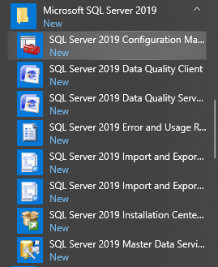
  - When you open SQL Server 2019 Configuration Manager, click on the “SQL Server Services” tab on the left-side panel to show the services as below:
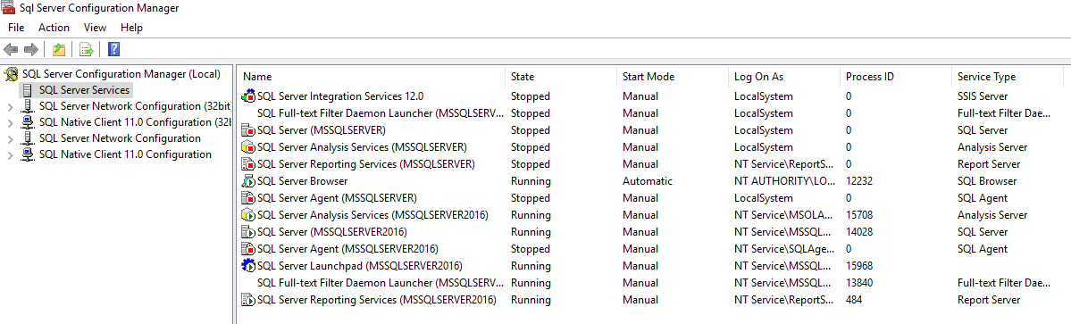
  - You can then right-click on the services with “Automatic” as their “start mode” and alter them. It is NOT recommended that you alter the SQL Server Browser service to Manual, but it’s OK to do so for all others.
- After installing the database, you must install the “Management Tools”. Return to the original installation dialogue as shown below:
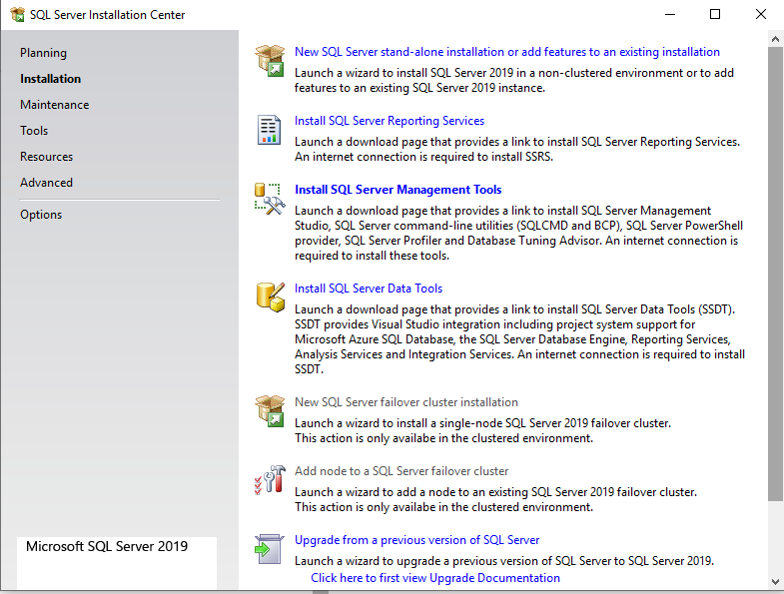
- Click on “Install SQL Server Management Tools”. This should take you to a website with the latest version of SQL Server Management Studio. Below is the way the link looked in May of 2020:
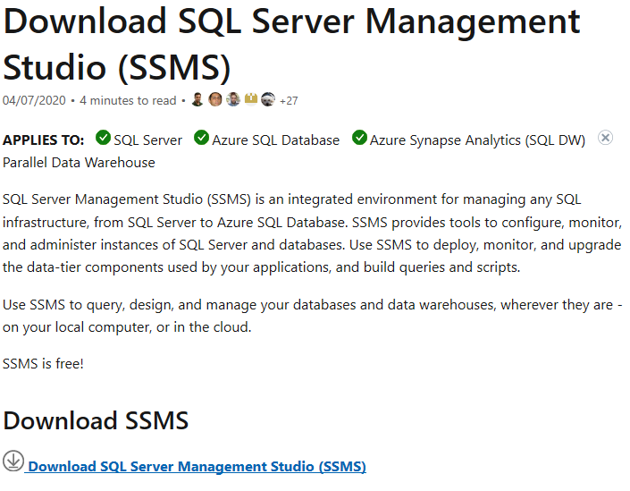
- Click on whatever the latest version is (18.5 as of May, 2020) and then run the installation. This is rather straightforward without any options to consider.

**Once you have completed your installation OR simply logged into a lab machine, perform the following basic commands to test out the system and to provide deliverables required for this assignment.
TEST BASIC COMMANDS:
EACH DELIVERABLE IS NOTED WITH TWO DOLLAR SIGNS IN FRONT ($$), COLORED RED AND IS WORTH 10 POINTS (partial credit will be given as appropriate)

- USE THIS WORD DOC AND INSERT THE DELIVERABLES WHERE INDICATED
- Click on the start menu and click on “Microsoft SQL Server Tools 18” to expand it.
- Click on “Microsoft SQL Server Management Studio 18” to open up SSMS, which is the primary interface for administrators and developers to query, configure and administer SQL Server. Below shows the Start menu selection:
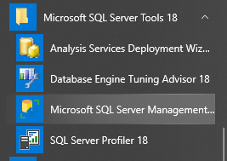
- The following prompt or something similar should appear:
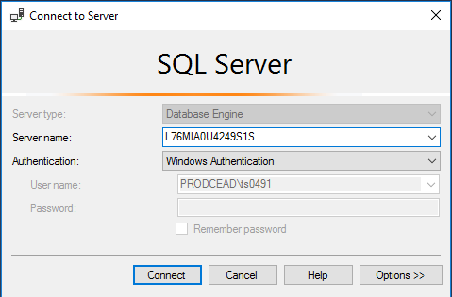
- $$DELIVERABLE (10 points) - Take a screenshot of the login prompt including the server name and paste it below:
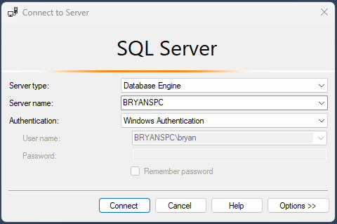
- The “Server name” should be your machine name or IP address. Your Windows userid should have permission to connect (whether on your machine or in the lab), thus “Windows Authentication” should work. Worse case, you can also logon using “SQL Server Authentication” with the “sa” userid and the password you provided during the installation. Click “connect”.
  - IMPORTANT NOTE FOR LAB USERS: Take note of the server name! It should be the name of your lab PC. If it is not, then change it to your current lab PC. You will need to do this every time you use the lab machines – another reason that a personal setup is preferred.
- Once connected to your database instance, click on “New Query” as shown below:
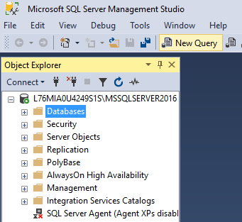
- Type in “use msdb; select * from INFORMATION_SCHEMA.TABLES” and then click on “Execute”.
- $$DELIVERABLE (10 points) – Take a screenshot of your entire screen, including the output of the query and paste it below:
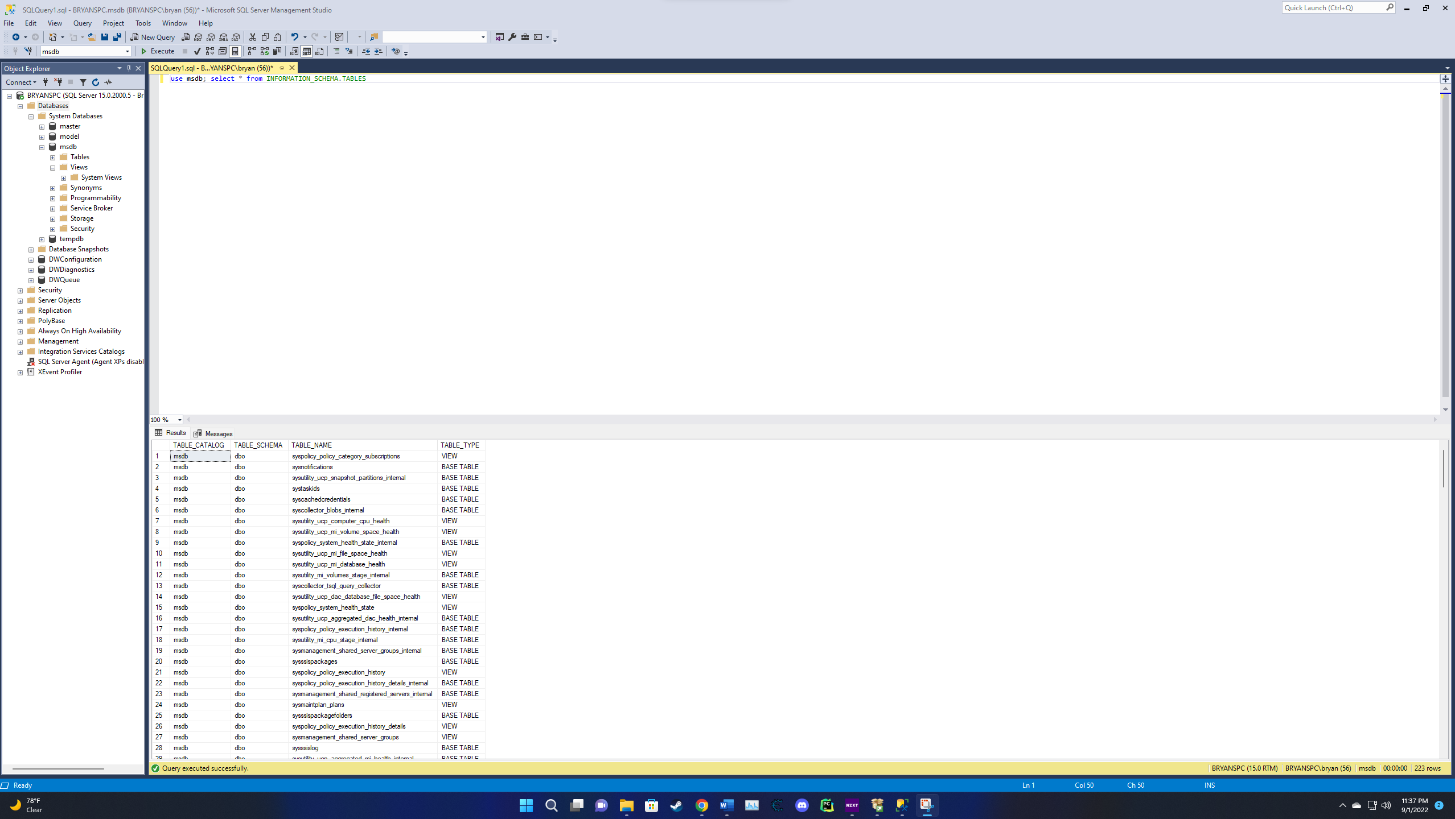
- $$DELIVERABLE (10 points) – What is this showing you? Answer the question below:
The Query that was provided when executed shows a list of tables from the database titled msdb. This is shown by the use msdb in which its asking to pick the msdb database followed by a select * from Information_Schema.tables. When this entire query is executed it provides us with the following results table catalog, table schema, table name and table type that is in the information_schema.tables stored in the msdb database.

- Type in “exec sp_helpdb” and then click on “Execute”.
- $$DELIVERABLE (10 points) – Take a screenshot of your entire screen, including the output of the query and paste it below: 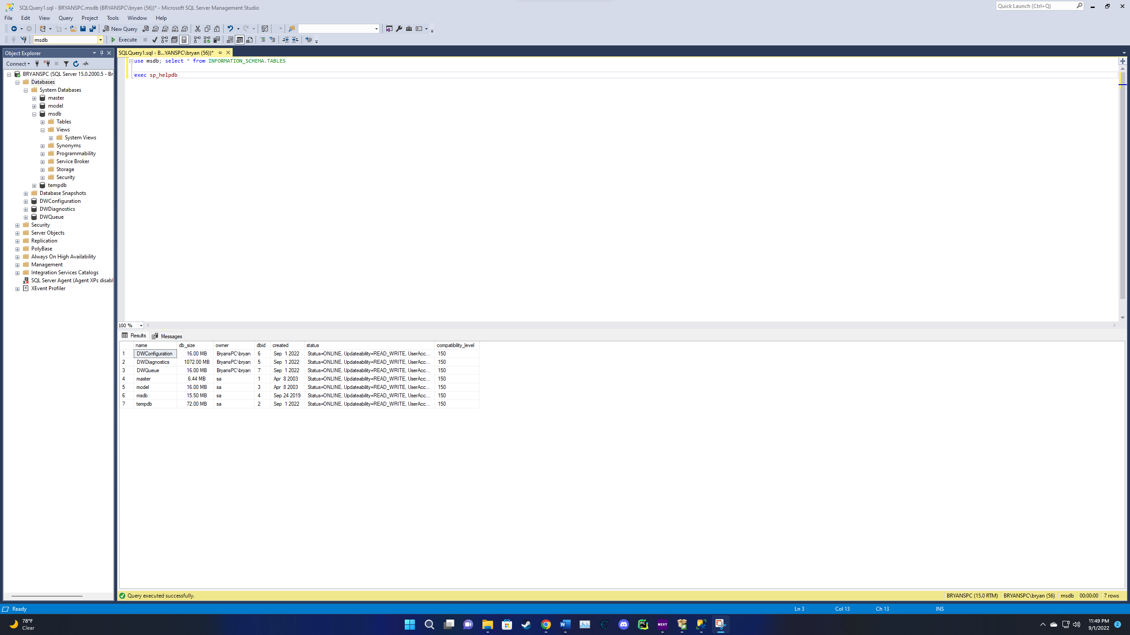

- $$DELIVERABLE (10 points) – What is this showing you? Answer the question below:
The following query when executed shows us information about the databases in the system. This is evident by when executing it provides us with the names of the databases in the System database along with some additional information such as the status of the databases, the owners, when it was created, and the size of the databases.

- Type in “exec sp_who” and then click on “Execute”.
- $$DELIVERABLE (10 points) – Take a screenshot of your entire screen, including the output of the query and paste it below: 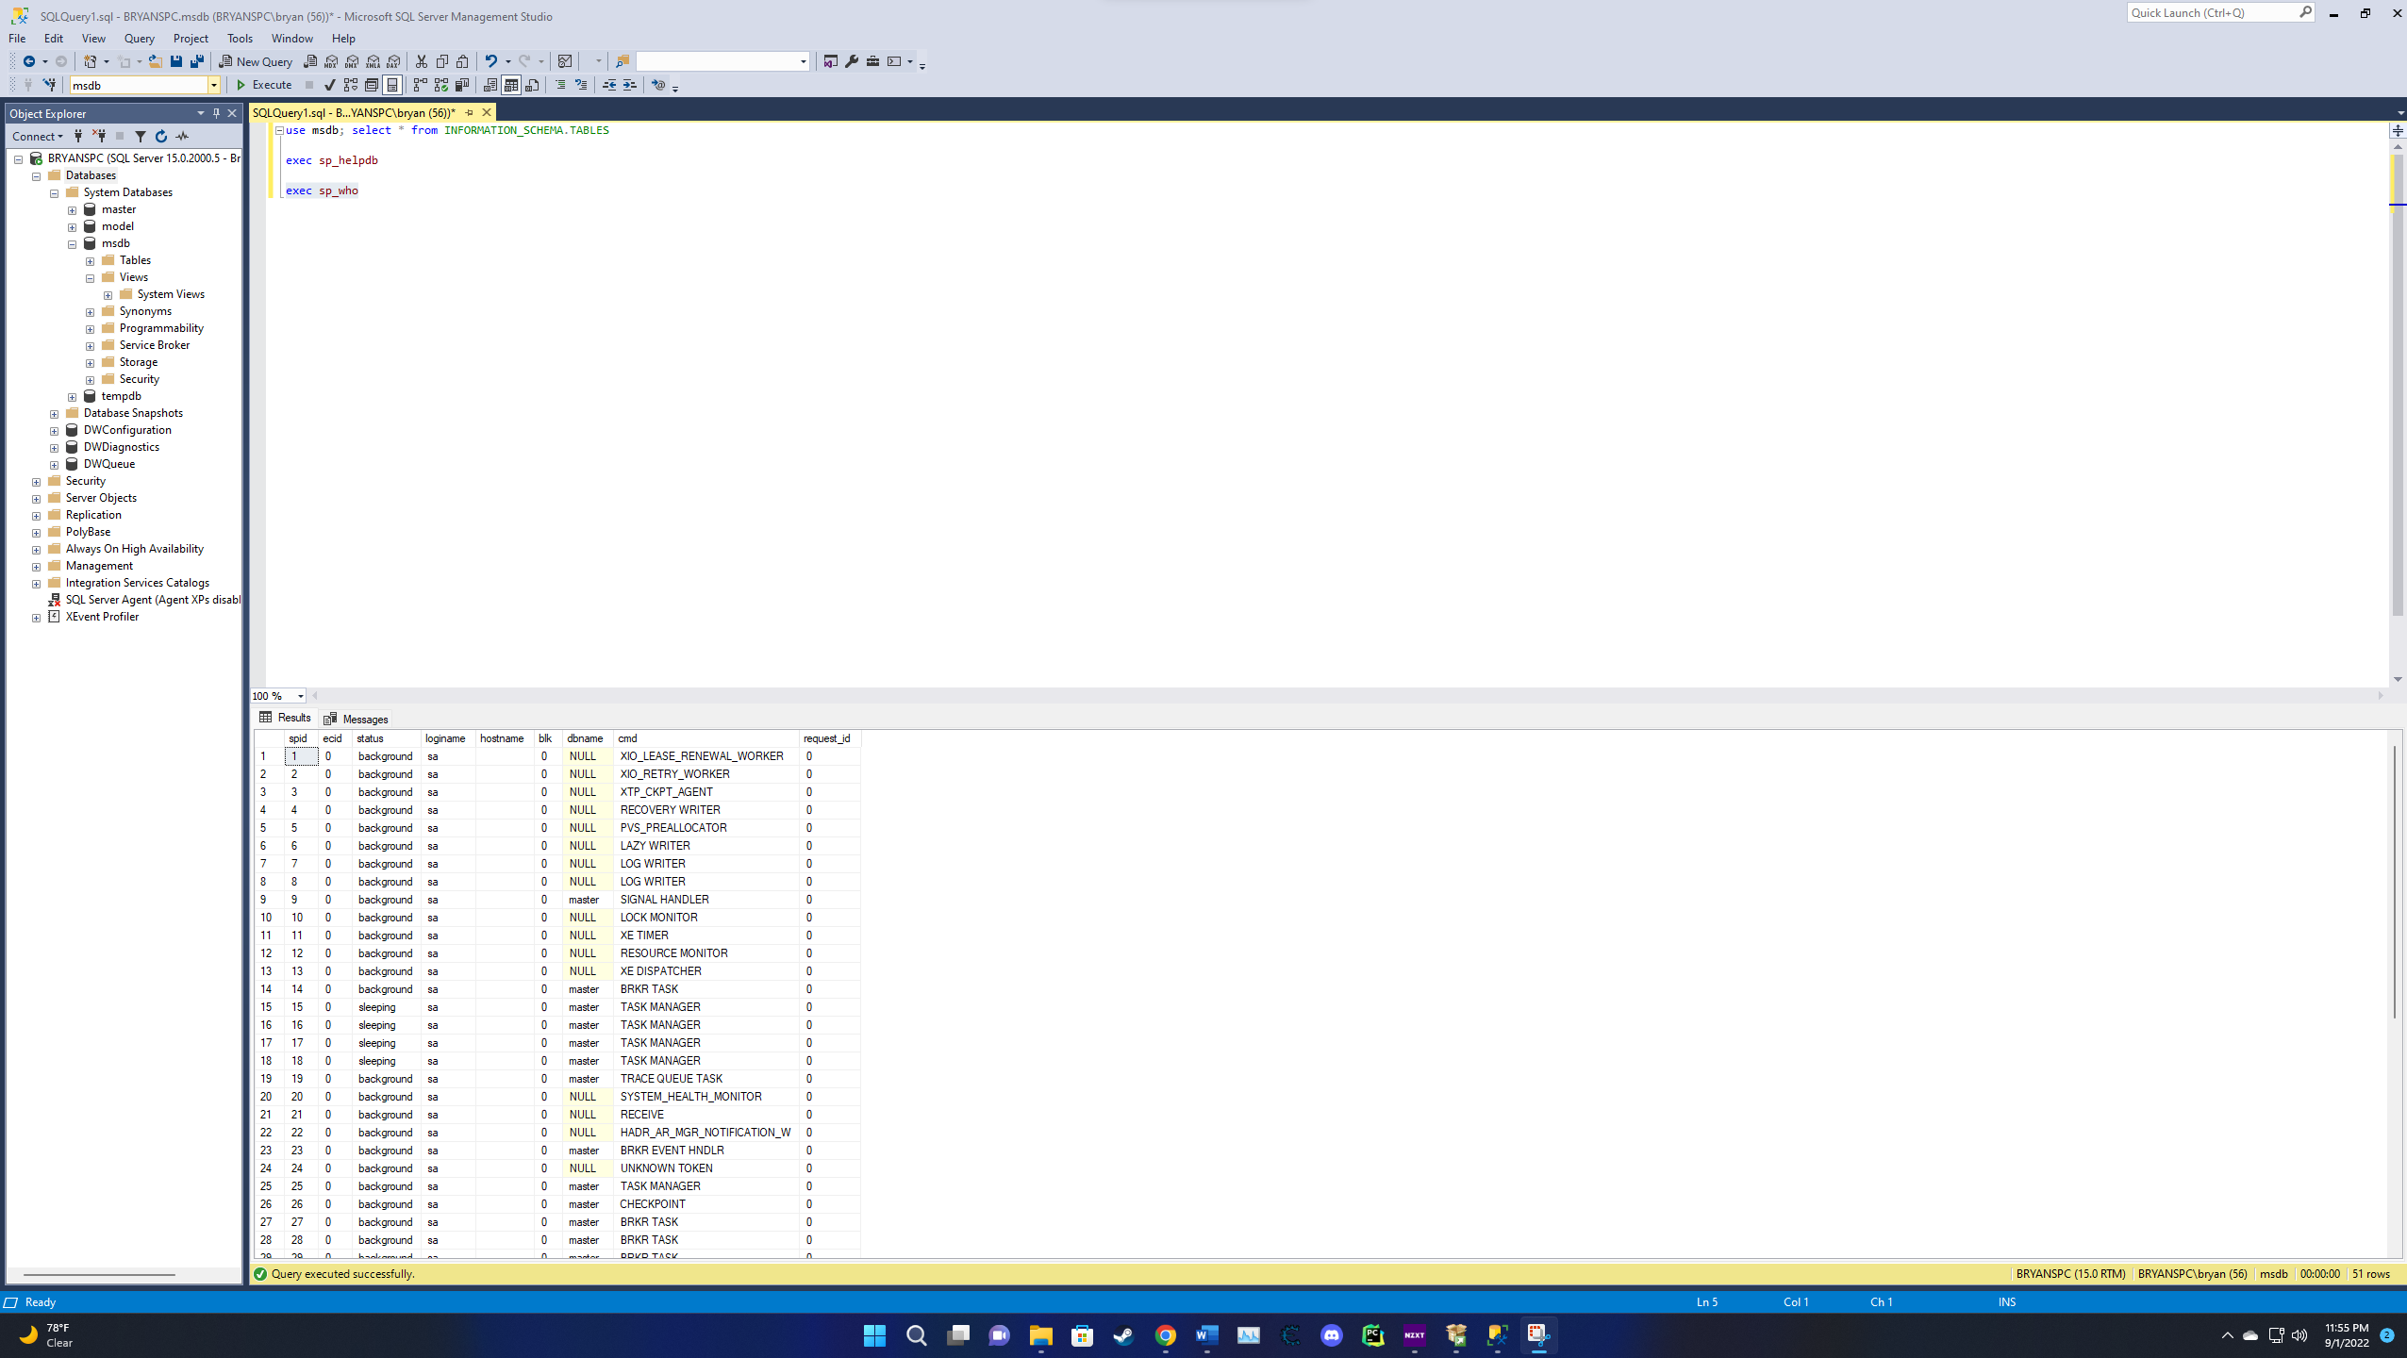

- $$DELIVERABLE (10 points) – What is this showing you? Answer the question below: The query executed provides information such as the current users, sessions, and the processes. This is shown as we have a status column showing us what is the process doing and also, we are provided with a login name and hostname column which tells us the current users in the Microsoft SQL Server Database.

- Expand the “Databases” node, then the “msdb” node, then the “tables” node and finally the “system tables” node. Then right click on the first system table and select through as shown below to Script the table to the query window.
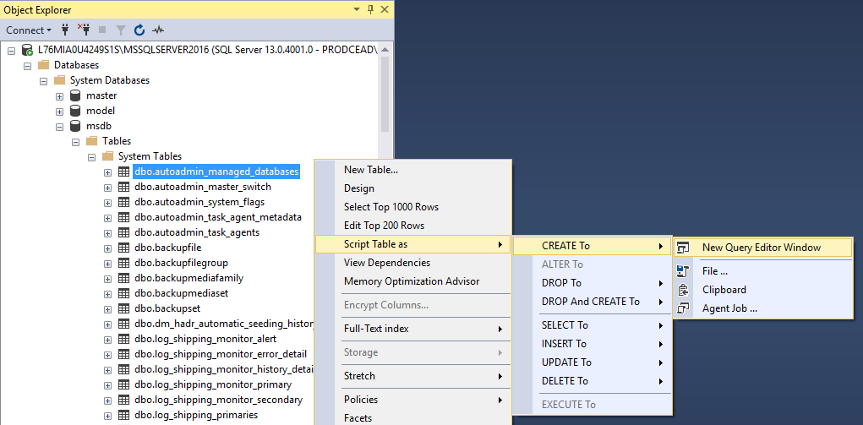
- $$DELIVERABLE (10 points) - Copy the resulting contents from the query window to the word doc below:

USE [msdb]
GO

/****** Object: Table [dbo].[autoadmin_managed_databases] Script Date: 9/2/2022 12:01:08 AM ******/
SET ANSI_NULLS ON
GO

SET QUOTED_IDENTIFIER ON
GO

CREATE TABLE [dbo].[autoadmin_managed_databases](
[autoadmin_id] [bigint] IDENTITY(1,1) NOT NULL,
[db_name] [nvarchar](128) NOT NULL,
[db_id] [int] NOT NULL,
[db_guid] [uniqueidentifier] NOT NULL,
[group_db_guid] [uniqueidentifier] NULL,
[drop_date] [datetime] NULL,
CONSTRAINT [autoadmin_managed_databases_pk] PRIMARY KEY CLUSTERED
(
[db_name] ASC,
[db_id] ASC,
[db_guid] ASC,
[autoadmin_id] ASC
)WITH (PAD_INDEX = OFF, STATISTICS_NORECOMPUTE = OFF, IGNORE_DUP_KEY = OFF, ALLOW_ROW_LOCKS = ON, ALLOW_PAGE_LOCKS = ON, OPTIMIZE_FOR_SEQUENTIAL_KEY = OFF) ON [PRIMARY],
UNIQUE NONCLUSTERED
(
[autoadmin_id] ASC
)WITH (PAD_INDEX = OFF, STATISTICS_NORECOMPUTE = OFF, IGNORE_DUP_KEY = OFF, ALLOW_ROW_LOCKS = ON, ALLOW_PAGE_LOCKS = ON, OPTIMIZE_FOR_SEQUENTIAL_KEY = OFF) ON [PRIMARY]
) ON [PRIMARY]
GO

- $$DELIVERABLE (10 points) – What is this showing you? Answer the question below:
What the above action is showing is the process on how to create said table. The reasoning for this is because we can see from the very beginning, we are using the msdb database and further down into the line we are creating the table with the query create table, upon following this we can also see the constraints and other information that makes up said table that we are viewing.

- You can now experiment some more within SSMS as you wish or simply close it down.
- Type in “SELECT SERVERPROPERTY('productversion'), SERVERPROPERTY ('productlevel'),SERVERPROPERTY ('edition')” and then click on “Execute”.
- $$DELIVERABLE (5 points) – Take a screenshot of your entire screen, including the output of the query and paste it below:
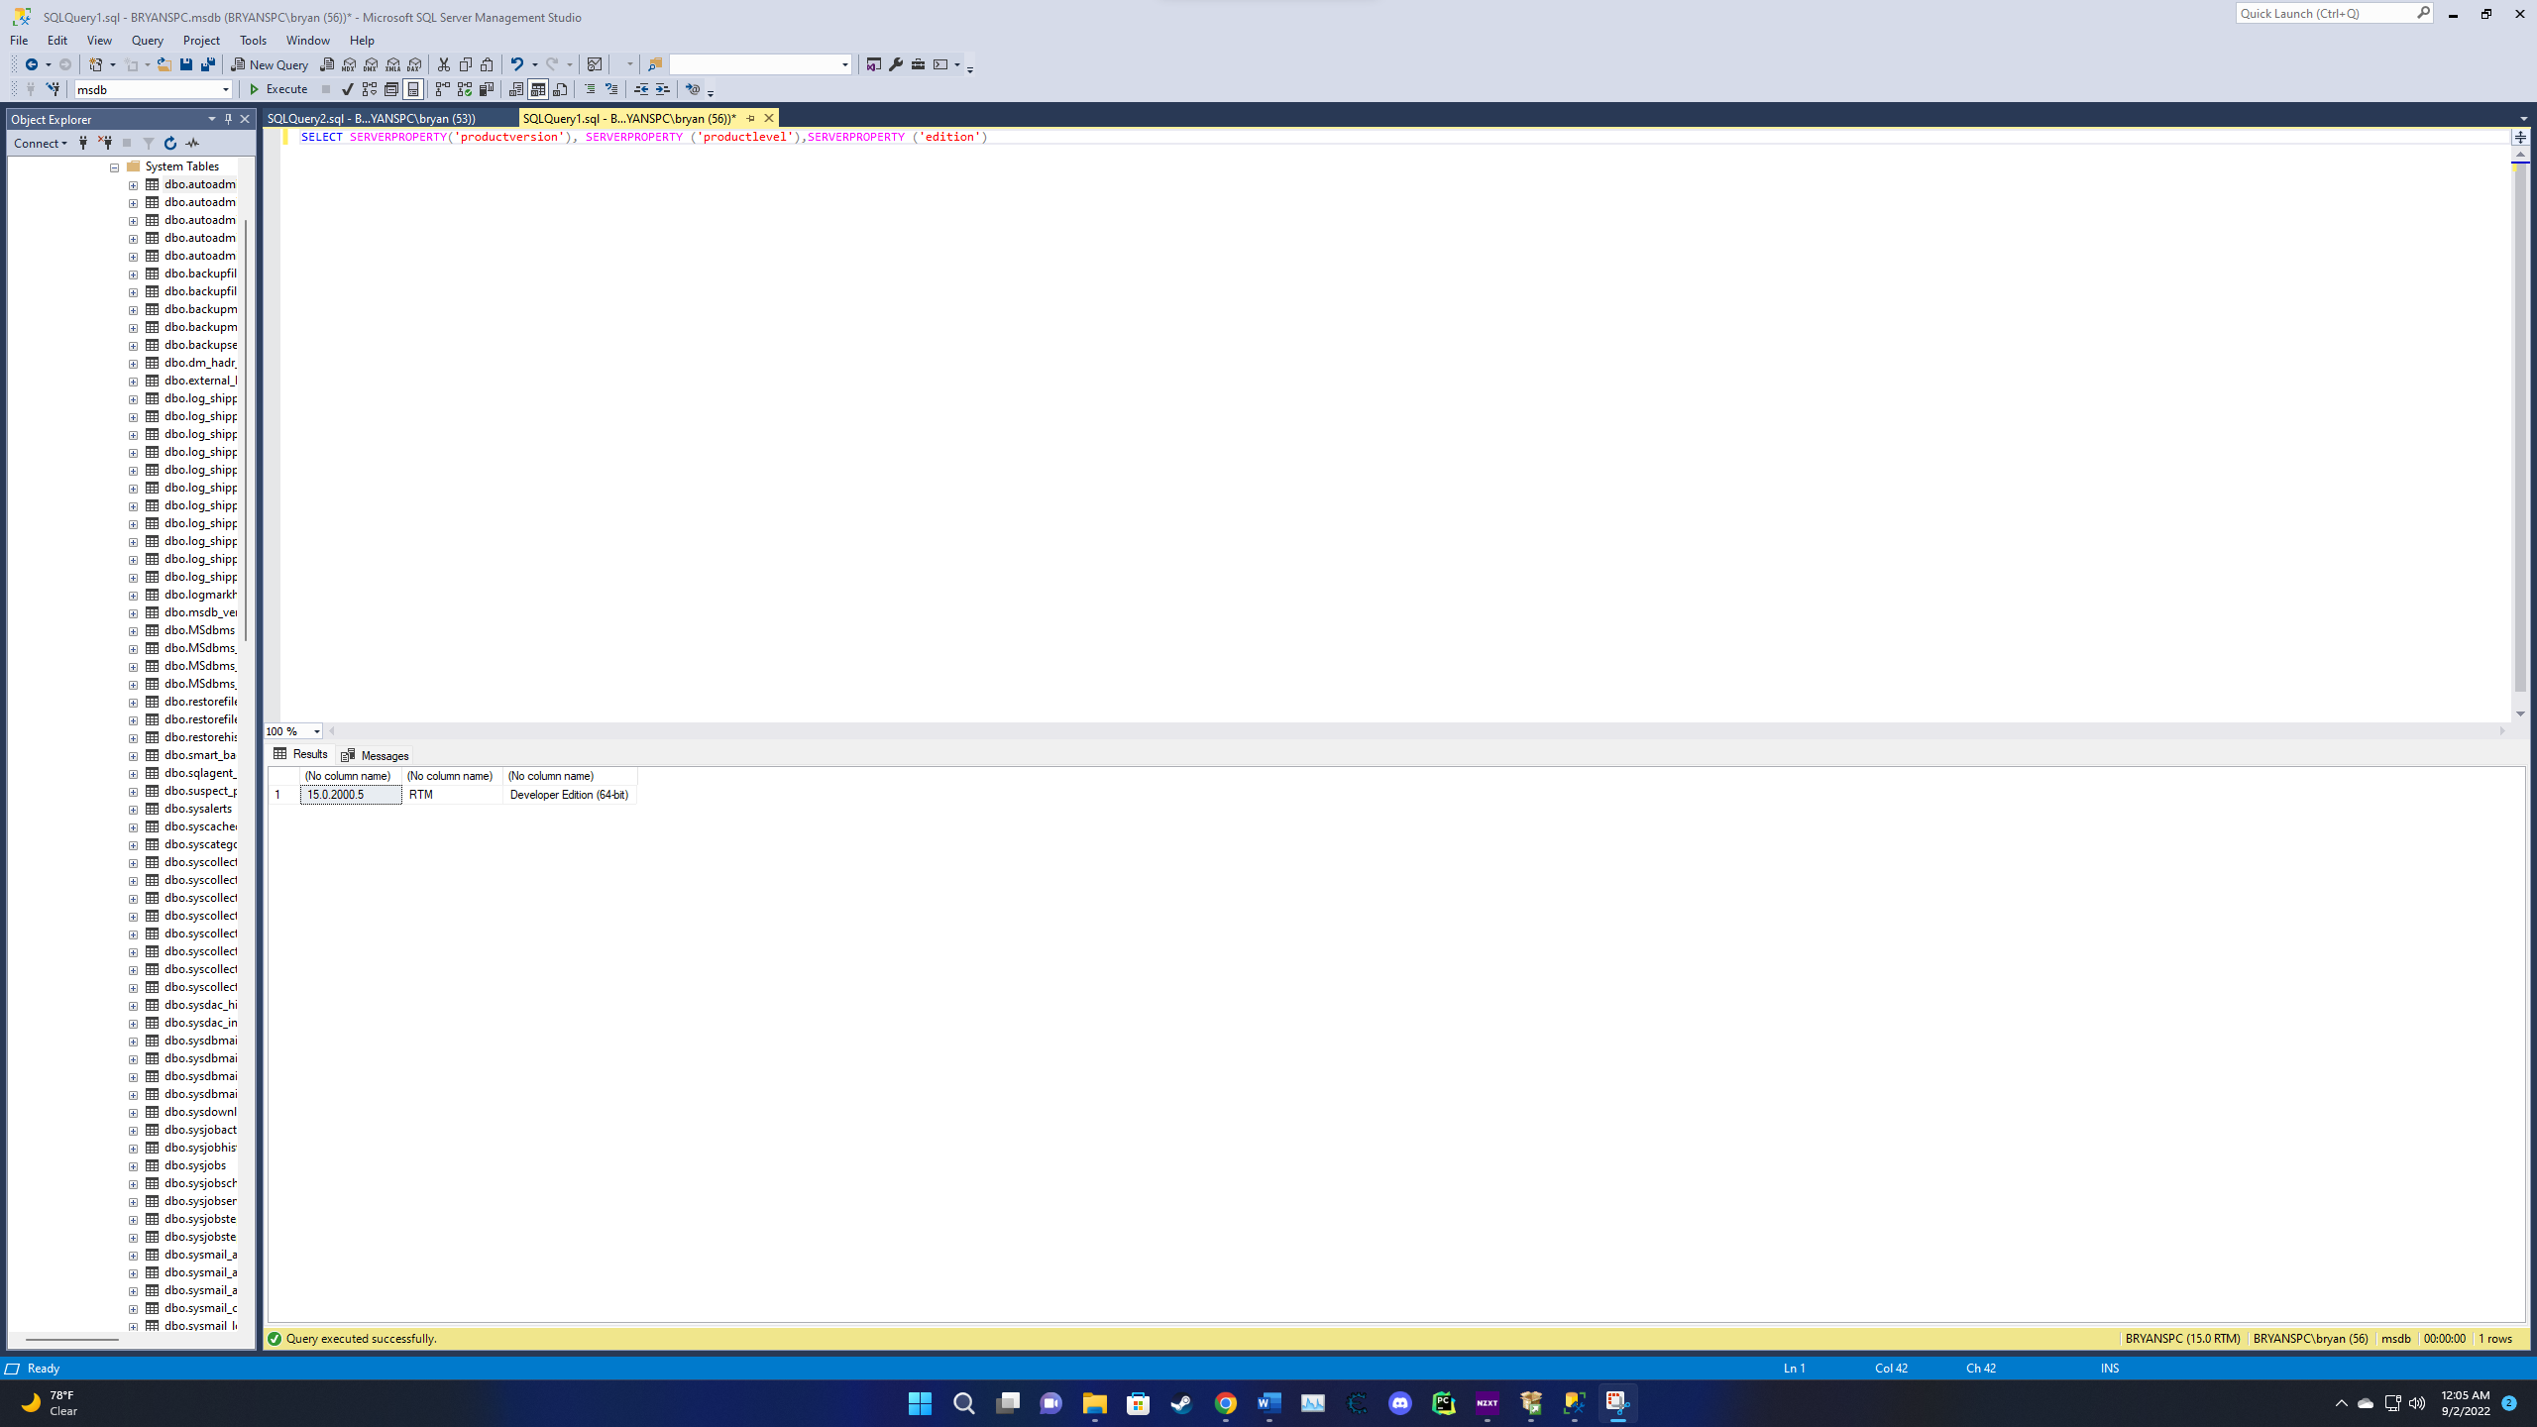
- Click on the start menu and click on “Microsoft SQL Server 2019” to expand it.
- Click on “SQL Server 2019 Configuration Manager” to open it up. This interface allows administrators to configure the Windows Services associated with SQL Server. Developers would not typically use this tool, except on their own PC. SSMS and SQL Server Configuration Manager are the two tools that we will be working with most in this course.
- $$DELIVERABLE (5 points) - Take a screenshot of the SQL Server Configuration Manager tool with SQL Server Services selected on the left pane and paste it in the word doc below:
